You are the Dal to my Pie
Inspired by


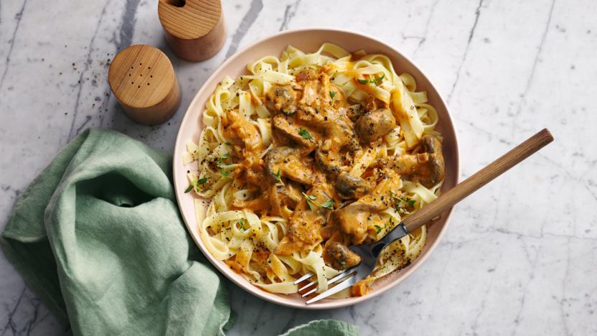
DID YOU KNOW?
“COOL FACT HERE ABOUT LENTILS!”

Nutrition – Total / Per Serving
Calories: ?kcal / ?kcal
Carbohydrates: ?g / ?g
Protein: ?g / ?g
Fat: ?g / ?g
Fibre: ?g / ?g
Sugar: ?g / ?g
Ingredients
350g of baby potatoes
1 onion
1 carrot
4 garlic cloves
1 tin of green lentils
250g of halloumi (or paneer)
1 tbsp tomato puree
1 tin of light coconut milk
1 vegetable stock
100ml of water
3 tsp Baharat seasoning






Good for:

Star Rating:





Method
Step 1 - Preparation
Preheat your oven to 220°C.
Dice the onion, halloumi, and garlic.
Cut your potatoes and carrot into bite size chunks.
Drain and rinse the lentils.
Heat some olive oil in your frying pan.

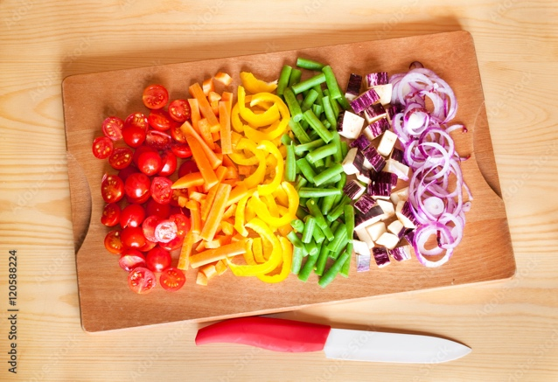
Step 2 – Fry It Up!
Once the pan and oil are hot, place the halloumi in it. Season with salt & pepper.
Fry until golden on all sides, ensure to keep turning the halloumi to prevent them from burning. (~5 mins).
Once they are golden, place them in a bowl and set aside for later.
Place the pan back on heat and add some more oil.
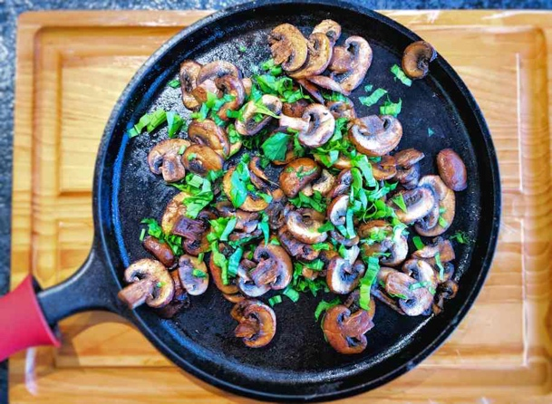
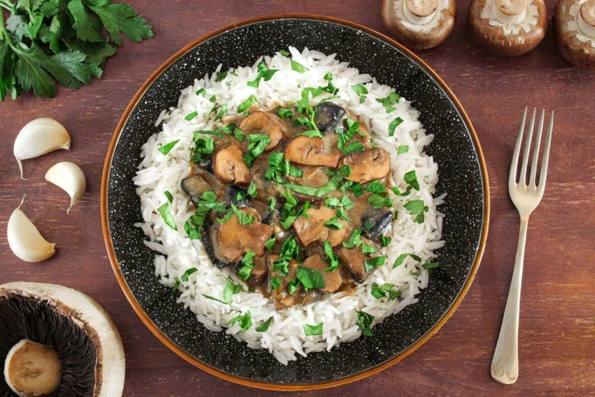
Step 3 – And Now We Simmer
Fry the onion and carrot until soft and tender (~5 minutes).
Season with salt & pepper.
Then add the garlic, tomato puree, and Baharat seasoning.
Place the halloumi back into the frying pan.
Stir and cook for 1 minute before adding in the coconut milk, water, vegetable stock paste, potatoes, and lentils.
Bring this all to a boil and then reduce the heat to a simmer until it has all thickened (~7 minutes).
Stir occasionally and don’t be afraid to add more water if it’s looking a bit dry.
Step 4 – Bake & Serve
Turn the heat off for the frying pan.
Season the mixture with salt and pepper before transferring to an ovenproof dish.
Bake your pie until the potatoes are cooked through (~15-20 minutes).
Once finished, remove the pie from the oven, allow it to stand for a few minutes before serving.

Enjoy!

